Multiple Face Recognition For Attendance Monitoring

| Katherine S. Villegas  BS Computer Science  Candelaria, Quezon, Philippines  ksvillegas1@up.edu.ph | Professor Toni – Jan Keith Monserrat  Philippines  tjkpmonserrat@gmail.com |
| --- | --- |

# ABSTRACT

Attendance, an important and compulsory tool in the process of learning, is included in the grading scheme of some instructors and professors in the University of the Philippines Los Baños. However, the existing attendance monitoring methods being used are tedious and occasionally unreliable. To solve this, an application was created where it is able to identify faces in the picture that belongs to the section and records the data for attendance. The application uses default frontal face haar-cascade for face detection and Local Binary Patterns Histograms for face recognition. Given a threshold, the application must correctly recognize faces in an image. Furthermore, data of the class and recognized faces should be recorded. After using the application on pictures taken from an IT1 laboratory class, students that belongs the section/group were recognized and recorded while those who are not were ignored. Furthermore, the accuracy of the application depends on the training data set that will be used. For enhancement, other Face Recognition algorithm can be used and the training data set can be enlarged. Attendance monitoring system can also be created where it will use the application and its output data for attendance.

# INTRODUCTION

Attendance is an important and compulsory tool in the process of learning. In the University of the Philippines Los Baños, attendance is included in the grading scheme of some instructors and professors. In fact, there is a UP Code on Attendance (Chapter 50, Art. 346) stating that if a student lost 20% of the hours scheduled in a subject, he shall be dropped from that subject. But despite the importance of monitoring the attendance of students, the existing attendance monitoring methods are not good and reliable enough.Furthermore, instructors and professors nowadays uses manual means of monitoring the attendance of students. Students’ attendance is normally taken by: using attendance sheets that are disseminated in class, requesting students to pass a piece of paper with their name, student number and section; having a seating arrangement and letting the Student Assistant to monitor the attendance; or by calling the students one-by-one. However, this methods are tedious, time consuming and unreliable.

Thus, creating an automatic attendance monitoring application can ease the means of checking the attendance of students. The application that was developed can recognize the faces in an image that belongs to the specified section. First, the application trains using the data set located on the folder with the name of the section specified. After training, faces are being detected on the input image. Each detected faces are being recognized if it belongs to the specified section. Once recognized, the data will be recorded in a database. Those faces that do not belong to the specified section will be ignored, thus making the application reliable. The training data set used contains the different facial expressions of the students in each section. Setting a threshold of the confidence value of the recognizer less than fifty can separate less accurate predictions. Lower confidence value of the recognizer means that the prediction is more accurate. Furthermore, the more images in the training data set, the higher accuracy of the application. This application can meet the needs of the instructors and professors of the Institute of Computer Science regarding the attendance monitoring in an easy and reliable way. Instructors, professors and student assistants will also be spared from the manual way of checking the attendance, which is a tedious task. ICS students can also benefit from this for they can study the application and create a complex system that will make use of the data chronicled by the application.

# RElated WorkS

One of the studies that tried to create a solution in the attendance monitoring is the research paper entitled An Attendance Monitoring System Using Biometrics Authentication. This system uses human fingerprint characteristics to issue the employees’ attendance [8]. Another study uses ID card barcode readers to record the attendance of the students. The system’s implementation is divided into three parts which are the Client Program Implementation, Server Program Implementation and Online System Implementation. All parts are implemented in Microsoft Visual Studio 2003. The database system of attendance record has six schemas which includes the Events, Attendance, Students, Departments, Places and Users [5]. In addition, a study uses a Radio Frequency Identification (RFID) system in the attendance monitoring problem. RFID technology uses electronic passive and active tags with suitable readers to facilitate the automatic wireless identification [2]. One more study implemented an android mobile application on smartphones to automate the attendance monitoring system. This study reduces the need of pen and paper manual attendance tracking and additional biometric scanner device for attendance checking. The employees’ time and attendance tracking is determined by the GPS using smartphone [9].

One of the studies that uses face recognition to record the attendance of students is the Integrated System for Monitoring and Recognizing students during Class Session. This student attendance system uses biometric authentication protocol and was made in the Al Zaytoonah University of Jordan. It uses face detection and face recognition to facilitate the checking of attendance in the classroom [1]. Another similar system is the Smart Attendance using Real Time Face Recognition which was developed in the Sri Lanka Institute of Information Technology. This system monitors the attendance of employees. Haar cascade was used in the human face detection. While a simple Principal Component Analysis was used to recognize human faces [7]. Moreover, a system developed in Saintgits College of Engineering in India is consists of a high resolution digital camera to monitor the classroom or the office room. Cameras are embedded on a microcontroller which enables it to rotate in left and right directions. The images obtain by the camera are sent to a computer programmed system that compares the it with a set of reference images of the students. This system uses Principal Component Analysis and the Eigenfaces approach in face recognition [3]. The mentioned systems are reliable and efficient, one the other hand installing and maintaining these systems are costly. However, a similar system was developed in the University of the Philippines Los Baños that automates the checking of attendance based on their location and seat plan by taking an image of the top-front position of the classroom. Nonetheless, the system relies only on the seat plan [4].

Contrary to these researches, this study implemented an attendance monitoring that is not costly by just using resources that are already available or easy to have, specifically a camera or any device that can capture recognizable images like a web camera. With images captured every session of the class and the different facial expressions of students that belong to the class, attendance monitoring can be automated and reliable enough. The different images of students are used as the training data set for the application to recognize the students that belongs in the class. While the images captured in every session is the basis to determine the students who are present during the sessions.

# METHODOLOGY

## Graphical User Interface (GUI)

The graphical user interface for the Multiple Face Recognition application is created to help the users use the application in an easier way. In the GUI, users will just have to input the subject and the section of the class and at the same time the image taken as the attendance for that day or session.Once the process button is clicked, the Java program acquire the information from the GUI and sends them to the Python program using the execute method. This marks the start of the face recognition in the input image.

## Training Data Set

Training data sets are composed of images of the students that belong to the section or class. These are used to train the face recognition application to identify which of the students belong to the class is present in the input image as the attendance. In gathering the data set, each person was videoed while doing the different facial expression namely : happy, sad, normal, winking, sleepy, eyes closed, tongue out and angry. The frames of each videos are being turned into images using the capture feature of KMPlayer media player. These images are named after the student number of the students and added to the training data set of their class.The application will get the subject and section inputs of the user. These inputs will be used to search the folder of the training data set of the class. Once found, the application will go through all the images. This is done using the train method in the OpenCV Library. The train method of OpenCV needs the images and respective labels as the parameters. This is to correctly identify the images being trained.

## Face Detection

The application uses default frontal face haar-cascade for facial detection. This haar-cascade is an xml file which includes data that will look for a face in an image. Face Detection is being used twice in the application. First is for detecting the faces in the training data set, detected faces features are then gathered by the train method. And second in detecting faces in the attendance image input. In training data set, detected faces are being cropped from the original image while in attendance image, detected faces are being enclosed in a box.

## Face Recognition

The application uses the Local Binary Patterns Histograms (LBPH) algorithm for face recognition. This was used because unlike the other algorithm, LBPH accepts inputs that are of different size and does not require same light settings of the training data set and the attendance image to accurately identify a face. And in this algorithm, the number of images per person in the training data set is directly proportional to the accuracy for recognition. Face Detection and Face Recognition works simultaneously. Once a face is detected in the attendance image, the recognizer will predict who is the detected face. The recognizer will output the label or the student number of its predicted face and the confidence level of its prediction. The confidence level of the prediction is inversely proportional to the correctness of the prediction. A threshold is being set to identify if the prediction of the recognizer will be accepted to be correct or not. If accepted, the student number of the student will be written above the box of the recognized face.

## Data Storage

Recognize faces will be stored in the database. This will serve as the attendance of the class. In each recognized faces, the student number, subject, section and the current date is being sent to the database.

# eVALUATION

The Multiple Face Recognition application was tested using the data and images of IT1 AB -8L class for accuracy evaluation. Twelve students where videoed for training data set and they were divided into two groups for testing the recognizer, moreover they are also photographed as one section to further test the recognizer in identifying faces from a large set of images. The effectiveness and accuracy of the application can be measured by setting a confidence level threshold that is less than fifty. This threshold can be altered according to the quality of the training data set obtained and the attendance image input. The quality of the training data set can be evaluated and can be considered high quality if all the facial expression that can be captured on attendance image is considered. Each expression should have at least five images per student for the recognizer to be trained enough. Furthermore, the attendance image can be considered high quality of all the faces of the students in a class can be clearly seen on the image and faces should not be partially covered by other faces or materials because this will greatly affect the prediction of the recognizer.

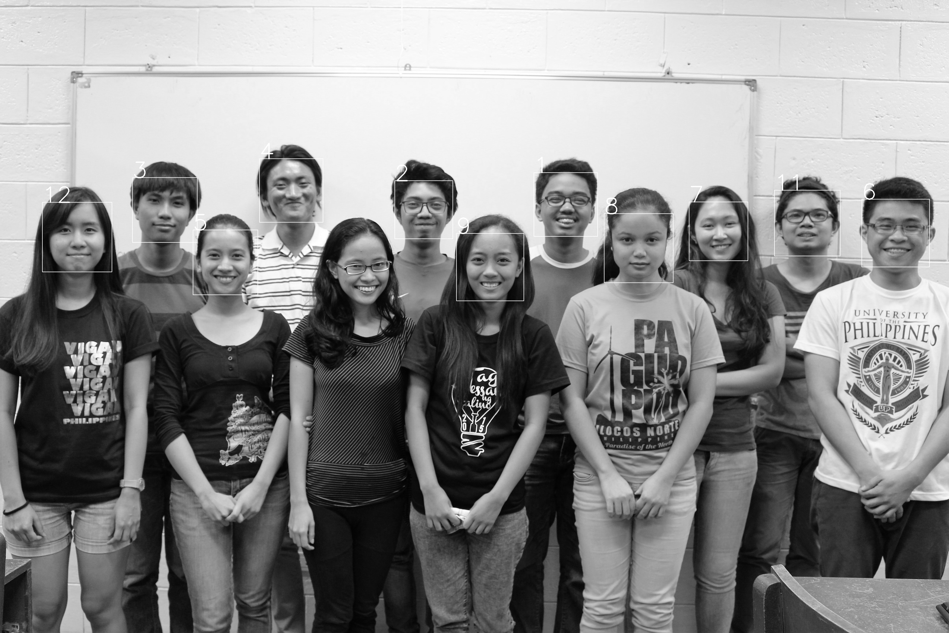For the experimental design, there are three test cases used for this application. The first one is using six students with good training data and attendance image. The second one is using also six students, but some of them do not have good training data, and the last one is using all the twelve students’ training data and identifying them to their whole class attendance image. All students have 70 images individually for the training data. All test cases have a varying threshold that is lower than 50. If faces will not be recognized under the threshold of below 50, the Multiple Face Recognition application is not effective enough for attendance monitoring.

# RESULTS

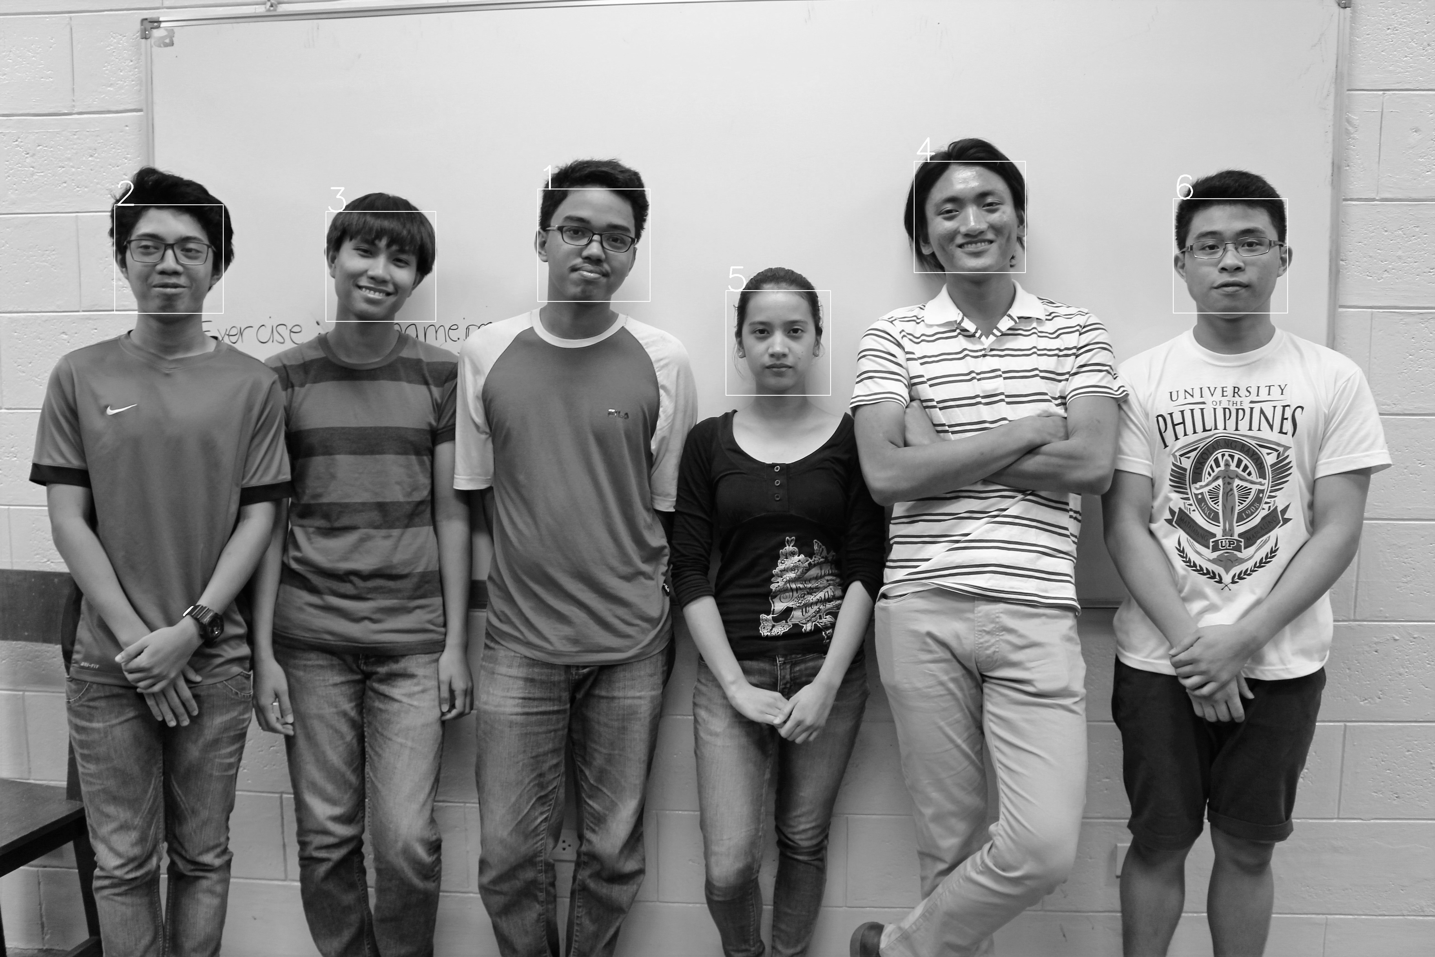The accuracy of the Multiple Face Recognition application depends on the data included in training and the input attendance image. The results for the three test cases are as follows:

**Figure 1. All students were correctly recognize**

For the first test case, the attendance image used is where all the six students are present. All six students were correctly recognized for the first attendance image with the threshold set to 40.

For the second image, one of the six students is absent. All the five students were recognized, and the student who was absent was not recorded as present. The threshold for this image is also 40.

For the second test case, five students were correctly recognized and one student, the one whose face is in a side view position, was not. The threshold for this image was 45. For the second image, two students whose faces are in a side view position were not recognized. On the other hand, the remaining students were correctly recognized with the threshold set to 45.

**Figure 2. Two students were not recognized**

For the third test case, all the students were recognized with the threshold set to 40 except for one. The one that is not recognized is the student whose face is in a side view position.

**Figure 3. One student was not recognized**

# DISCUSSION

From the results of the Multiple Face Recognition application, the training data have a big impact on the accuracy of the recognizer. Training data should have covered all the possible instances of the students’ faces. In the training data, only facial expressions like happy, sad, normal, winking, sleepy, eyes closed, tongue out and angry are taken and considered. These data can somehow give high accuracy for facial recognition. But for better results and high accuracy of the prediction of the face recognizer, other aspects should also be considered like different angles of the face and different light settings that can affect the facial features of the students. Making the training data set bigger can improve the accuracy of the face recognizer.

For the first test case, all students are correctly recognized for first and second attendance image with the threshold set to 40. This is because these six students have a good training data set. Facial expressions and angles of the faces that can appear in the attendance image were considered and were included in their training data set. Thus, the prediction of the recognizer gives a high accuracy.For the second test case, one student was not recognized by the recognizer. This is because in the attendance image, her face is in a side view position while no image in her training data set was in a side view position. All the images of the unrecognized student was facing straight forward towards the camera. The same goes with the second attendance image, the two students’ faces were in a side view position but all their training data set images were looking straight forward towards the camera. The same reason why on the third test case, the student whose face is in a side view position was not recognized.

Averaging the confidence level of all the prediction in the test cases, the application has 60.38% accuracy for the given data. The average confidence level for first test case is 69.43%, 49.28% on the second test case and 62.45% on the third test case. But then again, the accuracy of the Multiple Face Recognizer application can still vary and increase depending on the data set to be trained.

# CONCLUSION AND FUTURE WORKS

The Multiple Face Recognition Application aims to ease the means of checking the attendance of students. The application is created using Java programming language for the GUI and Python with OpenCV Library for the implementation of the face recognizer. The default frontal face haar-cascade is used for the facial detection feature and the Local Binary Patterns Histograms algorithm for the face recognition feature. Given a threshold less than fifty, the application must correctly recognize faces in an image. Furthermore, these recognized faces must be recorded to monitor the attendance of the students. After using the application on pictures taken from an IT1 laboratory class, students that belongs the specified section/group and has a quality training data set were recognized and recorded while those who are not were ignored. The application accuracy for all the test cases was 60.38%. This is computed by averaging the confidence level of the predictions done by the recognizer. On the other hand, the accuracy of the application depends on the training data set that will be used.

To enhance the system, other Face Recognition algorithm can be used and the training data set can be enlarged. Aside from capturing the different facial expressions of the students, other factor that can affect the facial features of the students can be considered. Some of these are the different angle of the face like when the students are looking to the right or to the left, and the different light setting. Through these enhancement, the face recognition can result to higher accuracy. An attendance monitoring system can also be created where it will use the application and its output data for attendance. With an attendance system, the means of checking the attendance of students can now be at ease.

# REFERENCES

1. Alia, M.A., Tamimi, A.A., AL-Allaf. O.N.A. (2013). *Integrated System For Monitoring And Recognizong Students During Class Session.* The International Journal of Multimedia & Its Applications, Vol. 5, No. 6, (December 2013) pp. 45 – 52.
2. Arulogun, O.T., Olatunbosun, A., Fakolujo, O.A., Olaniyi, O.M. (2013). *RFID-Based Students Attendance Management System.* International Journal of Scientific & Engineering Research, Vol. 4, Issue 2, (February 2013) pp. 1-9.
3. Joseph, J. (2013).  *Automatic Attendance Management System Using Face Recognition.* International Journal of Science and Research, Vol. 11, No. 2, (November 2013) pp. 327 – 330.
4. Invierno, I.D.C. (2013).  *Location-based Classroom Attendance Monitoring System for ICS Lecture Halls.* Published Undergraduate Special Problem, University of the Philippines Los Baños, Laguna, Philippines.
5. Kizildag, M., Basar, E., Celikag, M., Atasoylu, E., Mousavi, S. (2007). *An Automated Attendance Monitoringand Registration System for EMU’s SPIKE Seminar Series.* Eastern Mediterranean University.
6. Rojas, R.C. (2015).  *Face Detection for Attendance Monitoring.* Published Undergraduate Special Problem, University of the Philippines Los Baños, Laguna, Philippines.
7. Roshan Tharanga, J.G., Samarakoon, S.M.S.C., Karunarathne, T.A.P., Liyanage, K.L.P.M, Gamage, M.P.A.W., Perera, D. (2013). *Smart Attendance Using Real Time Face Recognition.* SAITM Research Symposium on Engineering Advancements, pp. 41-44.
8. Rao, S., Prof. Satoa K.J. (2013). *An Attendance Monitoring System Using Biometrics Authentication.* International Journal Of Advanced Research in Computer Science and Software Engineering, Vol. 3, Issue 4 (April 2013) pp. 379-383.
9. Sultana, S., Enayet, A., Mouri, I.J. (2015). *A Smart, Location Based Time and Attendance Tracking System Using Android Application.* International Journal of Computer Science, Engineering and Information Technology, Vol. 5, No. 1(February 2015) pp. 1 -5